**JVM Architecture**

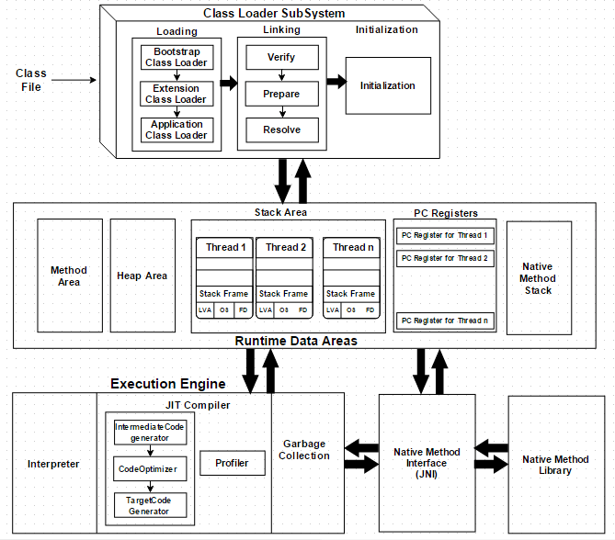

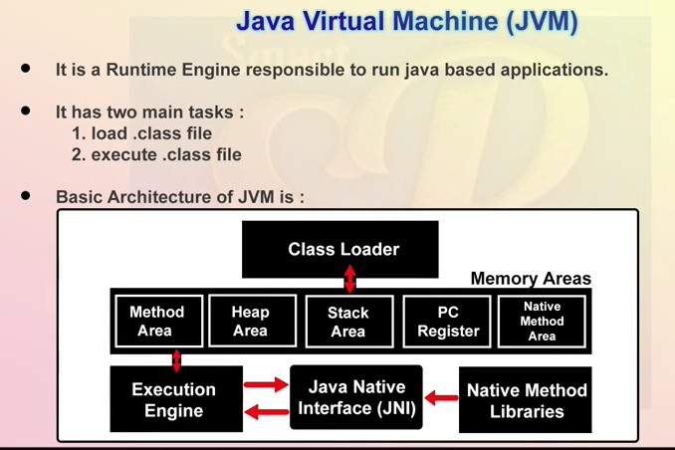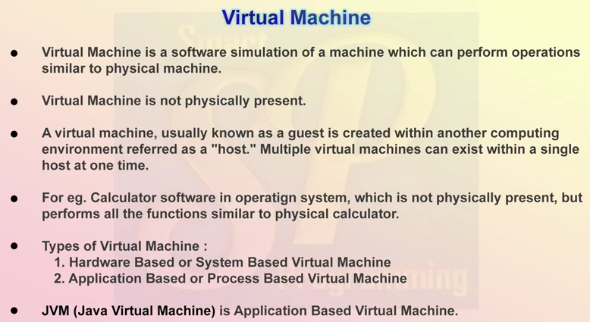

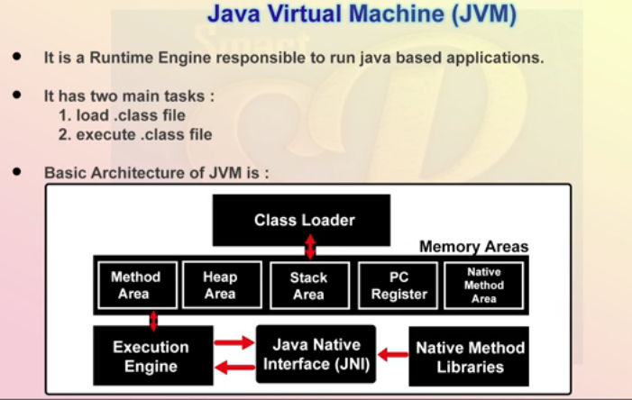

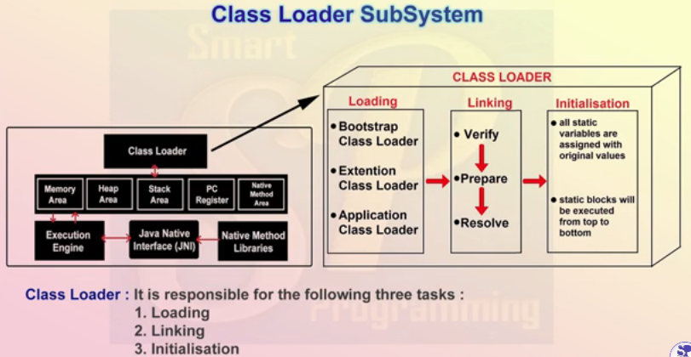

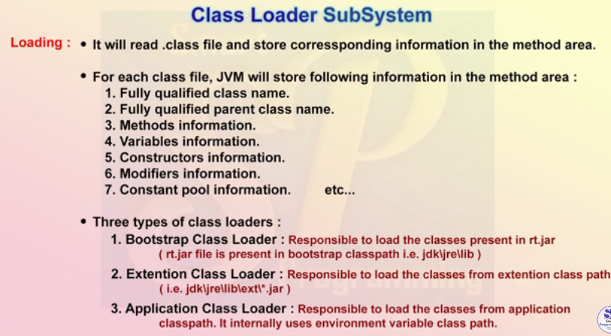

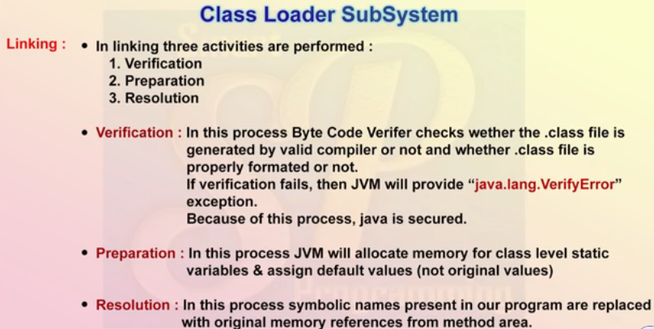

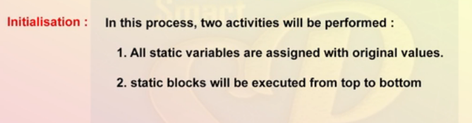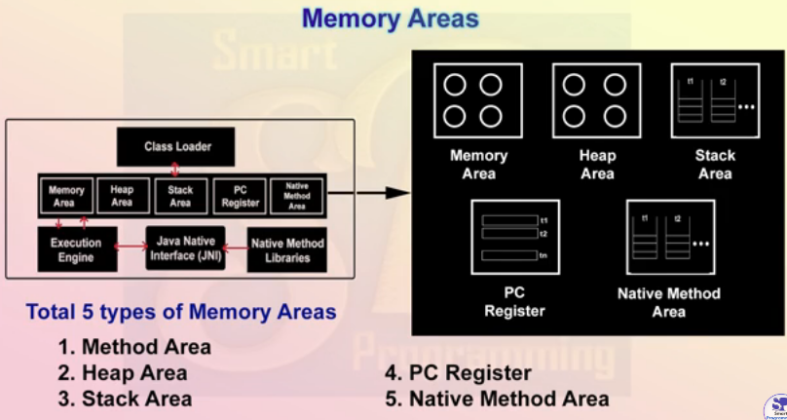

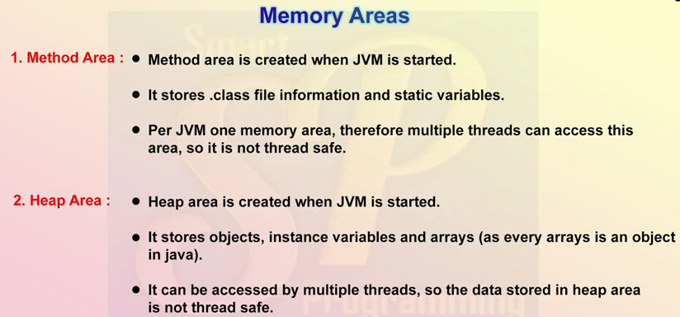

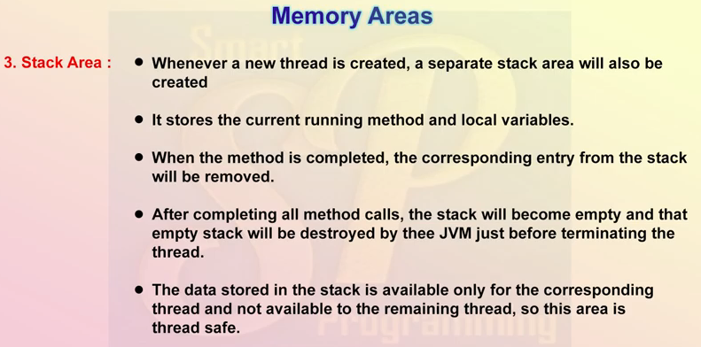

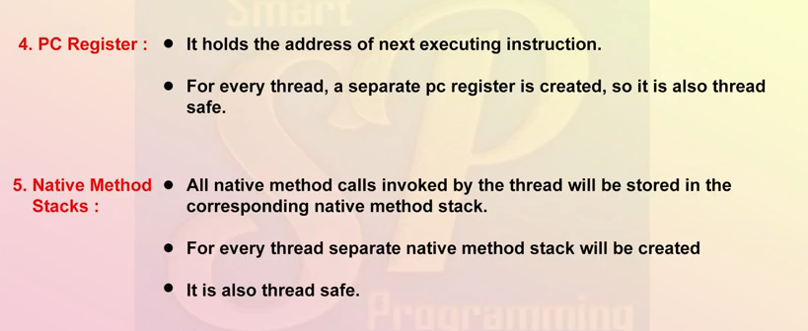

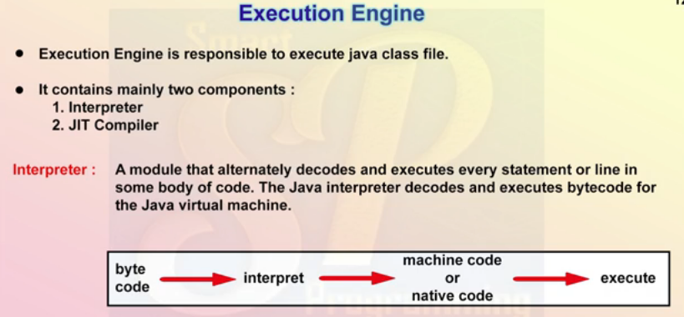

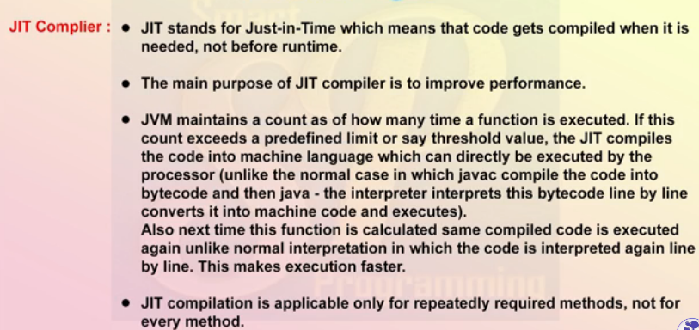

* **Intermediate Code Generator** – Produces intermediate code
* **Code Optimizer** – Responsible for optimizing the intermediate code generated above
* **Target Code Generator** – Responsible for Generating Machine Code or Native Code
* **Profiler** – A special component, responsible for finding hotspots, i.e. whether the method is called multiple times or not.
* ***Garbage Collector* :**Collects and removes unreferenced objects. Garbage Collection can be triggered by calling System.gc(). Garbage collection of the JVM collects the objects that are created.It destroy un-referenced objects.
* **Java Native Interface (JNI) :**  
  It is an interface which interacts with the Native Method Libraries and provides the native libraries(C, C++) required for the execution. It enables JVM to call C/C++ libraries and to be called by C/C++ libraries which may be specific to hardware.
* **Native Method Libraries :**  
  It is a collection of the Native Libraries(C, C++) which are required by the Execution Engine.

